# TRIBUTE PAGE

### A MINI PROJECT REPORT

#### Submitted by

#### Group No: 24

**Diksha Vadehra - 2310992592**

**Tathya Sachdeva - 23109992593**

**Aneet Kaur - 2310992594**

#### in partial fulfillment for the award of the degree of

## BACHELEOR OF ENGINEERING

***in***

COMPUTER SCIENCE & ENGINEERING



**CHITKARA UNIVERSITY**

**CHANDIGARH-PATIALA NATIONAL HIGHWAY**

**RAJPURA (PATIALA), PUNJAB-140401 (INDIA)**

##### OCTOBER, 2023

##### **TABLE OF CONTENTS**

|  |  |  |
| --- | --- | --- |
| Sr. No. | Section | Page No. |
| 1. | Introduction | 1 |
| 2. | Problem Statement | 2 |
| 3. | Technical Details | 3 |
| 4. | Key Features | 4 |
| 5. | Project Advantages | 5 |
| 6. | Result | 6-9 |
| 7. | Conclusion | 10 |

**Introduction**

In an era defined by digital connectivity and the ever-expanding range of the Internet the importance of preserving and commemorating the legacies of significant individuals or subject cannot be overstated. The tribute page website project endeavors to meet this need by creating a dedicated online platform where the accomplishments contributions and influence of Bill Gates are celebrated and made accessible to a global audience. This project stems from the recognition that in today’s fast paced world there is an increasing demand for easily accessible and comprehensive sources of information about Bill Gates who is leaving an indelible mark on various domains. His stories serve as a source of inspiration and enlightenment for generations to come.

The primary objective of the tribute page website project is to design and develop an interactive and user platform that pays tribute to Bill Gates. Through meticulous research thoughtful design and Seamless functionality, we aim to create an engaging space where users can dwell into the life achievements and impact of Bill Gates.

By creating a tribute page website, we endeavor to bridge the gap between historical and contemporary significance, making the stories of extraordinary individuals readily available to a global audience. This project not only serves as a test-statement to the accomplishments of Bill Gates being honored but also stands as a valuable source of education, inspiration and cultural enrichment.

**PROBLEM STATEMENT**

The problem that this project report aims to address is the lack of resources available to individuals or organizations who want to create tribute page websites. Many people may wish to honor and commemorate someone special by creating a dedicated website, but they often lack the technical knowledge or guidance required to do so effectively.

The absence of clear instructions and comprehensive guidelines on the technical aspects of creating a tribute page website can lead to suboptimal designs, poor user experience, and difficulties in organizing and presenting the content in a meaningful way. Additionally, the lack of information on hosting options and domain registration may further discourage individuals from making their tribute page accessible on the internet.

Therefore, the objective of this project report is to provide a comprehensive solution by offering detailed guidance and step-by-step instructions on the technical aspects of creating a tribute page website. It aims to empower individuals or organizations by providing them with the necessary information to design visually appealing, functional, and accessible tribute pages that effectively honor and commemorate the chosen individuals.

Additionally, this project report seeks to address the need for information on hosting options and domain registration, enabling users to navigate the process and make their tribute pages accessible on the internet under memorable domain names.

By addressing these challenges, this project report aims to fill the gap and provide individuals or organizations with the tools and knowledge needed to create meaningful tribute pages through websites.

**TECHNICAL DETAILS**

**Software**

* Visual Studio Code (HTML&CSS)

**Language**

* Hyper Text Markup Language (HTML)
* Cascading Style Sheet (CSS)

**Hardware**

* Intel(R) Core (TM) i5-1035G1 CPU @ 1.00GHz 1.20 GHz
* Graphic Card GEFORCE GTEX
* SSD 512GB
* RAM 8.00GB

**Internet Connection**

* Wifi 50 mbps

**KEY FEATURES**

1. **Subject Selection**: Meticulous process of selecting a subject with substantial influence in their respective field ensuring that the legacy alliance with the project’s goals have inspiration and education.
2. **Content Compilation**: Thorough research and verification of information to present a comprehensive overview of Bill Gates lives achievements and contributions along with cultural and historical content in which they thrived.
3. **Interactive Elements**: Engaging multimedia components image calories and links to external resources to provide a dynamic and immersive experience for users.
4. **Responsive Design:** Ensuring seamless accessibility across various devices including desktop, laptops, tablet and mobile phones to cater to a diverse audience.
5. **Source Verification**: Rigorous citation and validation of all information and media used in the website content to uphold the highest standards of accuracy and integrity.
6. **Timeline or Chronology**: Display key events and milestones in the Bill Gates’ life and career, providing a chronological narrative for users to follow.
7. **Quotations or Excerpts**: Highlight impactful quotes, excerpts from speeches, or significant writings of Bill Gates to provide deeper insights into their beliefs and philosophies.

**Project Advantages**

1. **Educational value**: Provides an opportunity for the project developer to conduct in depth research on Bill Gates gaining valuable knowledge about their life achievements and contributions.
2. **Digital Skills**: Development enhances technical skills in web development including HTML and CSS leading to a better understanding of front-end web technologies.
3. **Creative Expression**: Allows for creativity in design choices including layout colour schemes and multimedia elements enabling the developer to showcase their design abilities.
4. **User Experience Design:** Offers a chance to focus on users entered to design principles ensuring an intuitive and engaging browsing experience for visitors.
5. **Honouring Significances**: Provides a platform to pay homage to Bill Gatess preserving their legacy for future generations to appreciate and learn from.
6. **Information Dissemination:** Offers a centralised hub for users to access comprehensive information about the chosen subject contributing to the dissemination of knowledge.
7. **Inspiration and Motivation:** Serves as a source of inspiration for others highlighting the achievements and contributions of Bill Gates.
8. **Digital Portfolio Addition**: Acts as a tangible project to include in a developer’s portfolio showcasing their skills in web development and design to potential employers or clients.
9. **Public Engagement**: Encourages interaction with wider audience allowing for feedback and potentially sparking discussions about Bill Gates.
10. **Demonstration of Commitment:** Demonstrates a commitment to personal academic development showing dedication to seeing a project through from conception to completion.

**RESULT**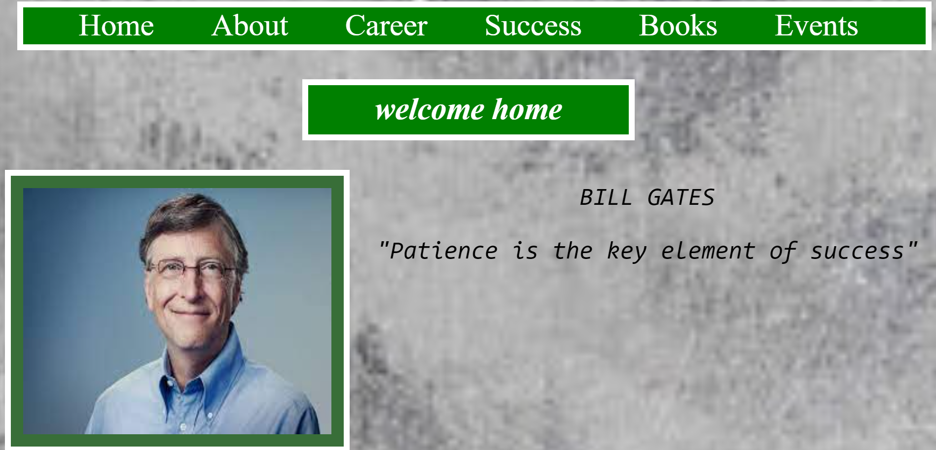

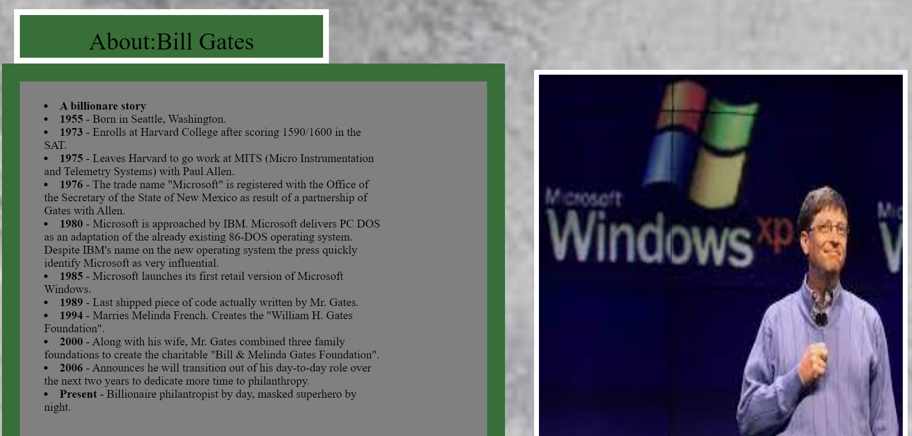



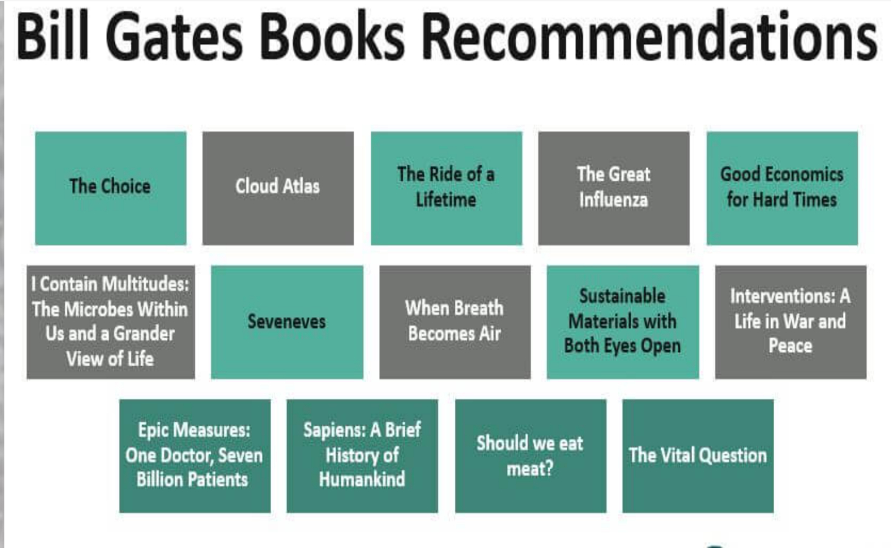

**CONCLUSION**

The completion of the Tribute Page Website project marks a significant milestone in our endeavour to honour and commemorate the contributions of a noteworthy individual. Through meticulous research, thoughtful design, and seamless functionality, we have successfully created a platform that serves as a fitting tribute to their legacy. This project allowed us to delve deep into the life and achievements of our chosen subject, gaining a profound understanding of their impact on society. We have strived to present this information in a user-friendly and visually appealing manner, ensuring that visitors can engage with the content and gain valuable insights.

The incorporation of interactive elements, such as image galleries and multimedia components, adds a dynamic dimension to the website, enriching the user experience. Additionally, the comprehensive citation and source verification process ensures that the information presented is accurate, reliable, and verifiable. Throughout the development process, we paid careful attention to accessibility, ensuring that the website is usable across various devices and adheres to accessibility standards. This commitment to inclusivity underscores our dedication to making the tribute accessible to a diverse audience.

In creating this Tribute Page Website, we have not only paid homage to a remarkable individual, but we have also contributed to the preservation of their legacy for generations to come. This platform stands as a testament to their enduring influence and serves as a source of inspiration and knowledge for all who visit. We extend our heartfelt gratitude to all those who supported and contributed to this project. Their insights and collaboration were invaluable in shaping the final outcome.